**Azure Instance Launch**

1. Login to below site

[**https://portal.azure.com/**](https://portal.azure.com/)

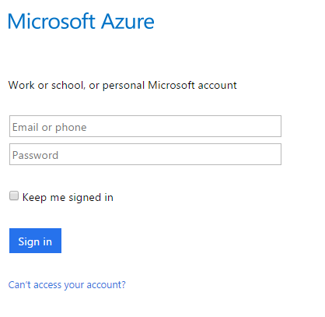

1. Enter Email or phone
2. Select type of account which you have created

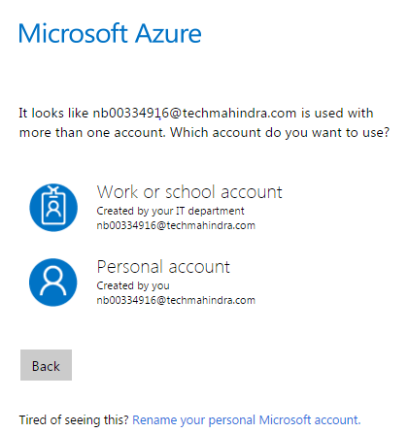

1. Enter password and click sign

